HIGH LEVEL DOCUMENTATION

Restaurant Rating Prediction

Pallav Chavda

### Contents

**Abstract**

1. Introduction 1

Why this High-Level Design Documentation 1

Scope 1

1. General Description 2

Product Perspective 2

Problem statement 2

Proposed Solution 3

Further Improvements 3

Data Requirements 3

Tools used 4

Constraints 4

Assumptions 4

1. Design Details 5

Process Flow 5

Model training and Evaluation 5

Deployment process 6

Event log 6

Error handling 6

1. Performance 7

Reusability 7

Application Compatibility 7

Resource Utilization 7

Deployment 7

1. Conclusion 8

Abstract

The restaurant industry is one of the prevailing competitive sectors. People enjoy cherishing communal dining for centuries, hence the demand for restaurants increasing day by day. Bangalore is a heaven for foodies with a range of cuisines from different parts of the world. In this paper, the data set for restaurants for a specific location is identified and the Data Visualization tools are applied to understand the trends and patterns of the food culture. This paper proposes a model to understand the factors affecting the rating of restaurants. Machine learning and predictive analytics with wide spread range of tools and techniques aids to predict the rating of restaurants. In this paper model is built using various regression algorithms and the most efficient algorithm is considered. The result of this model helps new restaurants in deciding their menu, cuisine, theme, cost, demographic location etc. thereby increasing the business.

# Introduction

### Why this High-Level Design Documentation

The purpose of this High-Level Design (HLD) Document is to add the necessary detail to the current project description to represent a suitable model for coding. This document is also intended to help detect contradictions prior to coding, and can be used as a reference manual for how the modules interact at a high level.

The HLD will:

* + Present all of the design aspects and define them in detail
  + Describe the user interface being implemented
  + Describe the hardware and software interfaces
  + Describe the performance requirements
  + Include design features and the architecture of the project
  + List and describe the non-functional attributes like:
    - Security
    - Reliability
    - Maintainability
    - Portability
    - Reusability
    - Application compatibility
    - Resource utilization
    - Serviceability

### Scope

This software system will be a web application, this system will be designed to predicts the restaurant rating based on the user's input in which there are several categories to fill in like the online order, table booking, votes, location, restaurant type, dishes liked, cuisines, type of restaurant and cost for two persons.

1

# General Description

### Product Perspective

This Restaurant rating system is a machine learning based model which will predict the rating of the restaurant.

### Problem statement

The main goal of this project is to perform extensive Exploratory Data Analysis(EDA) on the Zomato Dataset and build an appropriate Machine Learning Model that will help various Zomato Restaurants to predict their respective Ratings based on certain features.

2

### Proposed Solution

This system requires features like services provided by the restaurants like online order, table booking facility, what type and variety of food they provide, what is the location of restaurant and how many of such restaurants are there in different regions of the Bangalore, how many votes were given and the cost of 2 persons. Based on these features the system will predict the rating of the restaurants

### Further Improvements

As the data is not very huge our main aim is to complete this use case with machine learning algorithm as a best optimized solution, In future if we are expected to get more data and different categories, if needed we might use deep-learning algorithm to get best solution.

### Data Requirements

Data requirements completely depend on our problem statement.

3

### Tools used



### Constraints

This project is based on Bangalore(India) data, The model is biased for the Bangalore region only. This system might not get expected results for other part of the country.

### Assumptions

The main objective of the project is to implement the use case as previously mentioned (2.2 problem statement). This system will help us to predict rating of the restaurant available in Bangalore region. We assume that the system will help the organization to know the exact rating of their restaurants.

4

1. **Design Details**

### Process flow

Based on the use-case, we will use a machine learning base model.

Below is the process flow diagram is as shown below.

### Proposed methodology

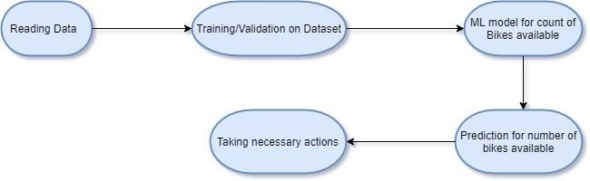

Selecting

Required Features for Prediction

ML Model For

Rating Prediction

### Model Training and Evaluation

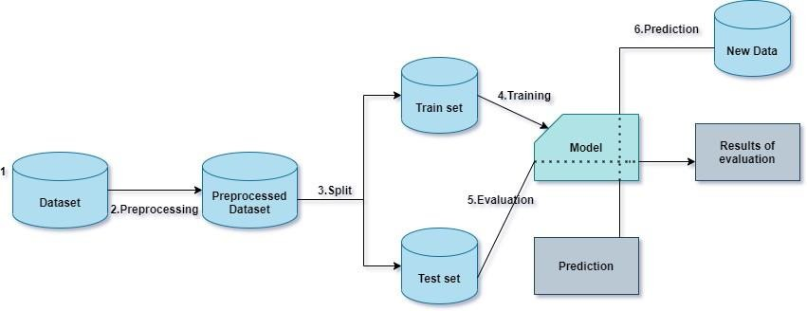

5

### Deployment Process

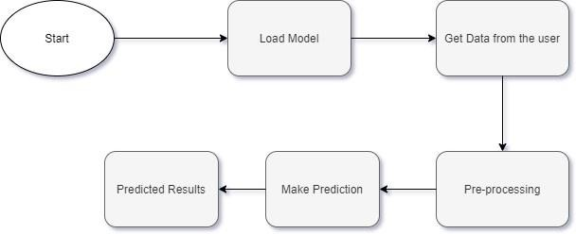

### Event log

The system should log every event so that the user will know what process is running internally.

**Initial Step-step description:**

* The system identifies at what step logging required
* The system should be able to log each and every system flow.
* Developer can choose logging method. We chose File logging.
* System should not hang as we have used file logging. Logging just because we can easily debug issues so logging is mandatory to do.

### Error Handling

Should error be encountered, an explanation will be displayed as to what went wrong? An error will be defined as anything that falls outside the normal and intended usage.

6

## Performance

### Reusability

The code written and the components used has the ability to be reused with no problems if there is similar problem statement.

### Application Compatibility

The different components for this project will be using Python as an interface between them. Each component will have its own task to perform, and it is the job of the Python to ensure proper transfer of information.

### Resource Utilization

When any task is performed, it will likely use all the processing power available until that function is finished.

### 

## Conclusion

This Restaurant Rating system is used in-order to provide required rating prediction to the customer and restaurant owners in the market by the organization. According to the different parameters by the restaurants, we as an organization should have an idea that what will be the rating of these restaurants so that organization can get maximum profit.

7